**Devops**

* **Devops is not a software or tool, it is a methodology 🡪 set of rules**
* **Rules between development activities and operational activities**
* **It reduces the gap between developer activities and operational activities(mainly it reduces time)**

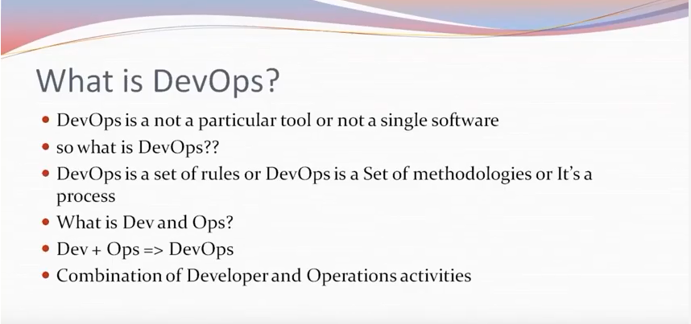

* **Devops defination 🡪 Software development method that stresses communication collabaration and integration b/w developer activities and operational activities**

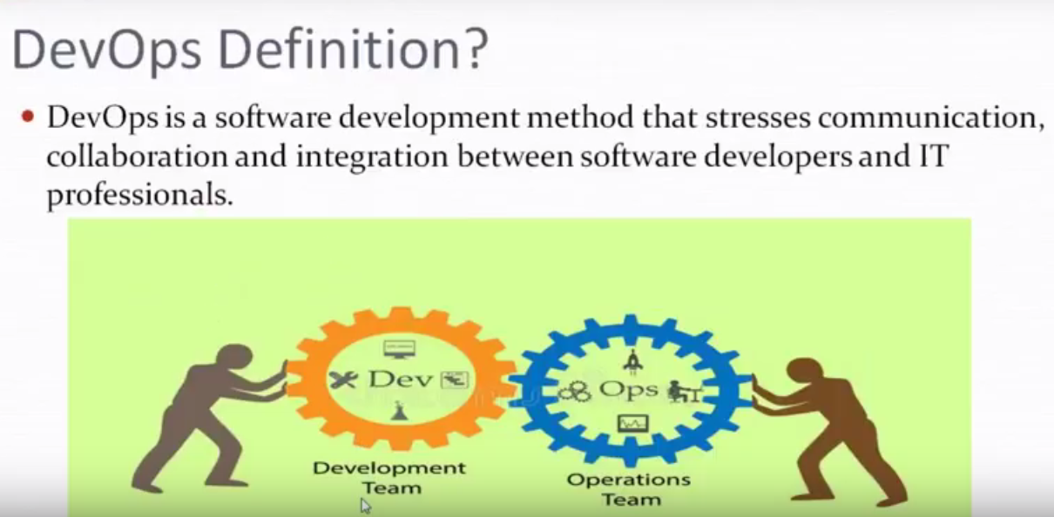

* **Overview of Build and Release**
* **By observing the diagram we can drag or we can conclude that CI&CD means there is continuous updation and continuous delivery of code to prod, i.e.,developer push their code to SCM and we configure all config details in Jenkins and whenever the code is updated it automatically the total process is repeated that is we mention the work flow in Job and for automation we use Cron Job. The code is sent to develop[er for testing irything is ok then it sents QA here too fine then sents to UAT(User Accepetance Test🡪 UAT means cients acts as a customer and tests all possibilities whether working or not if ot is ok then sents to prod otherwise sents back to debper to fix that problem after fixing again the process starts from first.**

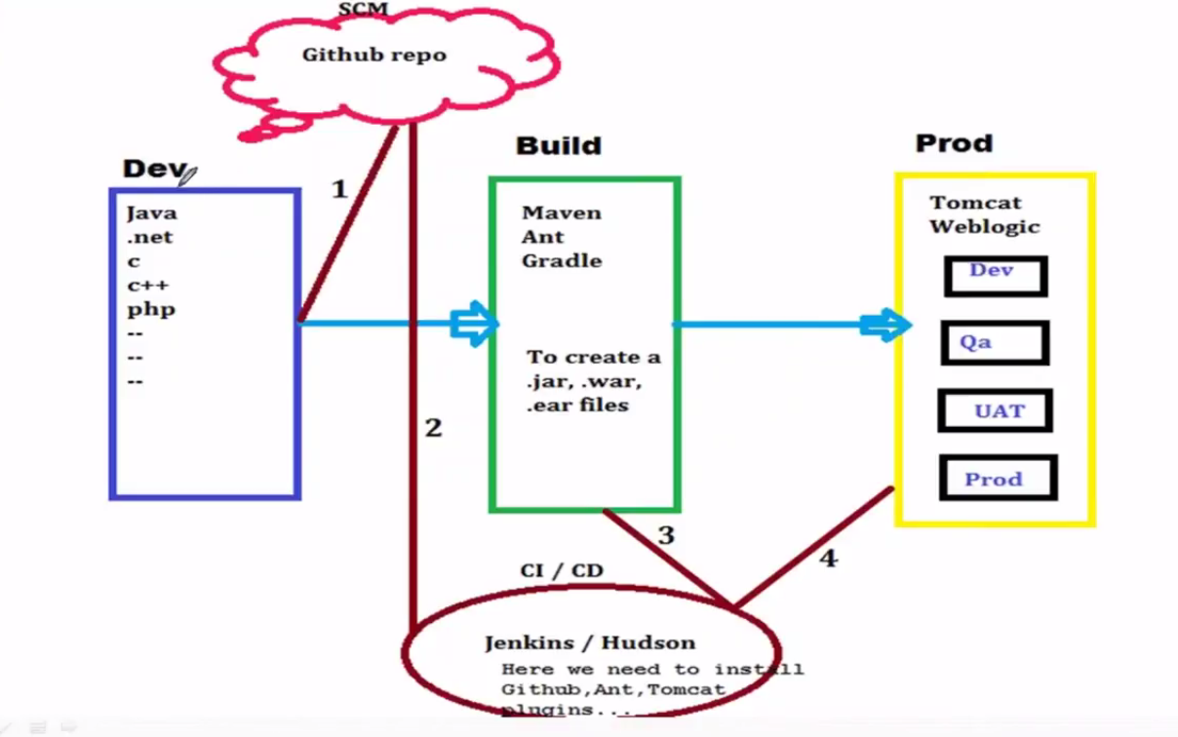

**Build Tools**

* **Build Tools are**

